Data-Driven Analysis of Bike-Share User Behaviour
Cyclistic Case Study Report
Jan Kodi
2025

Table of Contents

1.0 Business Task 3
2.0 Data Sources 4
2.1 Primary Data 4
2.2 Secondary Data 4
2.3 Data Limitations 4
3.0 Data Cleaning & Preparation 5
3.1 Data Consolidation 5
3.2 Data Cleaning 5
4.0 Analysis Summary 6
4.1Trends in Smart Device Usage 6
4.2 Application of Trends to Bellabeat Customers 6
5.0 Visualisation & Key Insights 7
6.0 Recommendations 10

Table of Figures

Figure 1: Time of Day 7
Figure 2: Day of Week 8
Figure 3: Month of Year 9
Figure 4: Users Per Birthyear 11
Figure 5: User Type Statistics 11

Business Task

Title: Cyclistic: Causal Vs. Members Analysis
Business Context:
Cyclistic is a Chicago-based bike-share company seeking to increase profitability. Their financial analyst team have determined that annual members generate more revenue compared to causal riders. And thus, the company wants to design a marketing strategy aimed at converting casual riders into annual members.
Objective:
The project aims to identify the key differences in how causal riders and annual members use the Cyclistic program, to design effective marketing strategies that encourages casual riders to convert to annual members.
Key Questions:
- How do annual members and casual riders use Cyclistic bikes differently?
- Why would casual riders buy Cyclistic annual memberships?
- How can Cyclistic use digital media to influence casual riders to become members?
Data Scope:
The analysis uses Cyclisitic historical trip data from 2019 – 2020.
Deliverables:
- A Tableau dashboard visualizing user behaviour patterns and differences between casual riders and annual members.
- A detailed executive report summarising findings, insights, and actionable recommendations for Cyclistic’s executive team.

2.0 Data Sources

2.1 Primary Data

The primary dataset used in this analysis is Cyclistics’ historical Bike-Share Trip Data, provided by Cyclistic. The dataset consists of individual bike trip records automatically collected through Cyclisitic’s bike-share system, where each record represents a single trip and including information such as trip start and end times, start and end station locations, bike id and user type.
The data covers a 12-month period from January 2019 to December 2019 and is provided in CSV format. In total, the dataset contains approximately 4 million records.
Key variables used in this analysis include:

- Trip ID
- Trip start time
- Trip end time
- Bike ID
- Trip duration
- Start station ID

- End station ID
- Start station name
- End station address
- User type
- Gender
- Birthyear
This dataset was used to analyse behavioural differences between casual riders and annual members and support recommendations aimed at increasing membership conversion.

Secondary Data

The primary dataset contained insufficient geographic data to utilise Tableau map features for each station. To address this, an auxiliary station lookup dataset was created. This was accomplished by using an external geocoding program (https://www.findlatitudeandlongitude.com/batch-geocode) to obtain accurate geolocation data for each station address listed in the primary dataset. This resulting dataset is saved as geocode-output.csv.
In conjunction with the primary dataset, this enabled Tableau map to be populated with each station, thereby allowing for a deeper and more comprehensive analysis.

Data Limitations

A review of the dataset did not identify any significant limitations that would substantially impact the outcome of this analysis. The dataset was considered very complete and consistent across all files.
Minor data preparation steps, such as standardising date formats and validating calculated fields, were performed as part of the normal cleaning process.

3.0 Data Cleaning & Preparation

3.1 Data Consolidation

The initial phase in preparing the Cyclistics’ historical Bike-Share Trip Data for analysis involved the consolidation of the raw data files. As the dataset, obtained from Cyclisitic, consisted of four separate CSV files, each corresponding to one quarter of the 2019 calendar year.
To streamline the analysis and enable more efficient cleaning, these files were merged into a single comprehensive dataset, ‘Divvy_Trips_2019.csv’. This was accomplished by developing a Python script, ‘merge_cyclisitic.py’, to maintain the datasets integrity.

3.2 Data Cleaning

Prior to analysis the dataset underwent a comprehensive cleaning and transformative procedure using R studio. The process involved several key steps to ensure the reliability and accuracy of the data:

- Removal of Duplicates: Duplicate records were identified and deleted, hence maintaining accuracy of results and subsequently preventing bias analysis.
- Time/Date Formatting Corrections: Date format was standardized to the Australian conventions. Additionally, any text-based timestamps were converted into datetime fields, ensuring uniformity for time-related analyses.
- Atomizing Column Fields: Fields such as ‘start_time’ originally consisting of both date and time information, were separated into distinct time and date columns to enable more precise time-series analysis.
- Handling Missing or Null Values: Instances of missing data were carefully identified and managed. For example, records containing null trip durations, data was inferred using start time and end time.
- Logical Fallacies: time checks were performed, and all falsies were identified and managed.
- Data Type Conversions: Text fields were converted to numeric or datetime types as necessary, enabling calculations and aggregation to be performed during analysis, specifically birthyear field.
- Standardisation of Station Names: Updating ambiguous or inconsistent field names to ensure reliable grouping and analysis.

*Complete cleaning log can be found in ‘cleaning_log.xslx’

4.0 Analysis Summary

4.1Trends in User Type Behaviour

The analysis of data revealed numerous key differences in behaviour between annual members and casual users. It was ultimately concluded that annual members were more likely to be employers who use the system to get to and from work, whereas casual users were more likely to use the system for recreational purposes. Several other notable trends included:
- Members logged almost 3 times the number of trips compared to casual riders, with 2.9 million trips vs 880K trips respectively.
- Casual riders logged 16% longer trip hours than members with 50M hours vs 42M Hours.
- Members gender ratio is 3:1 whereas casual ratio is 3:2
- Average trip duration for a casual user is approximately 57 minutes, whereas for members it is approximately 10 minutes.

4.2 Application of Trends to Cyclistic’s Marketing Team

Based on trip duration patterns, it is assumed that casual users with trips exceeding 30 minutes are likely using the bike-share system for exercise-related purposes, whilst those with trips under 30 minutes are more likely engaging in recreational use.
Given this distinction, it is recommended that the marketing team prioritise targeting casual users in the longer-duration segment, as this group is more likely to demonstrate behaviours aligned with regular and intentional usage, increasing the likelihood of conversion to annual membership. Given exercise trips are more likely to plan their usage in advance and demonstrate a higher level of intent and engagement.
In contrast, casual users with shorter trip durations are more likely to use the system spontaneously when bicycles are readily available, often for convenience or leisure rather than planned activity. As these trips typically require minimal preparation or commitment, this segment is less likely to convert to a paid membership.
Therefore, targeting the former is expected to stronger conversion outcomes and a higher return on marketing investment.

5.0 Visualisation & Key Insights
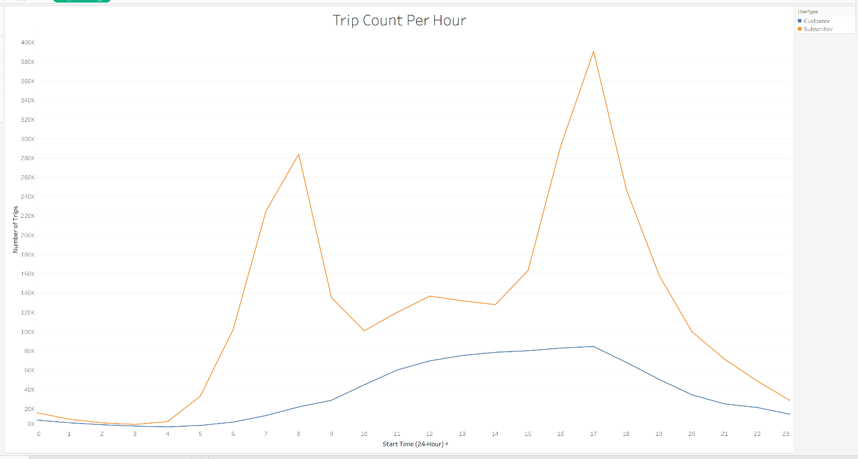
Figure 1: Time of Day
‘Trip Count Per Hour’ illustrates the distribution of the total trips throughout the 12-month period by hour of the day, amongst casual users and annual members.
The annual members graph suggests a commuter-driven usage pattern, with two clear peaks. The first at 8am, indicating a morning commute (~7-9am), and the second at 5pm, indicating an evening commute (~4-6pm). Outside of these peak periods, member usage remains relatively low, with the exception of a small peak at 12pm, likely to be caused by lunch time rush, before declining in the evening.
In contrast, casual users illustrate an entirely different behaviour in trip distribution throughout a day. The casual graph shows trip volume remaining low during the early morning hours then gradually increasing throughout the day, before peaking at 5pm. This suggests a more of leisure behaviour from the users, particularly during the afternoon to after-work hours.
Application of Analysis
These insights suggest that marketing strategies should be delivered during late afternoon to early evening hours, whilst casual engagement is at its highest, to maximize conversion likelihood.

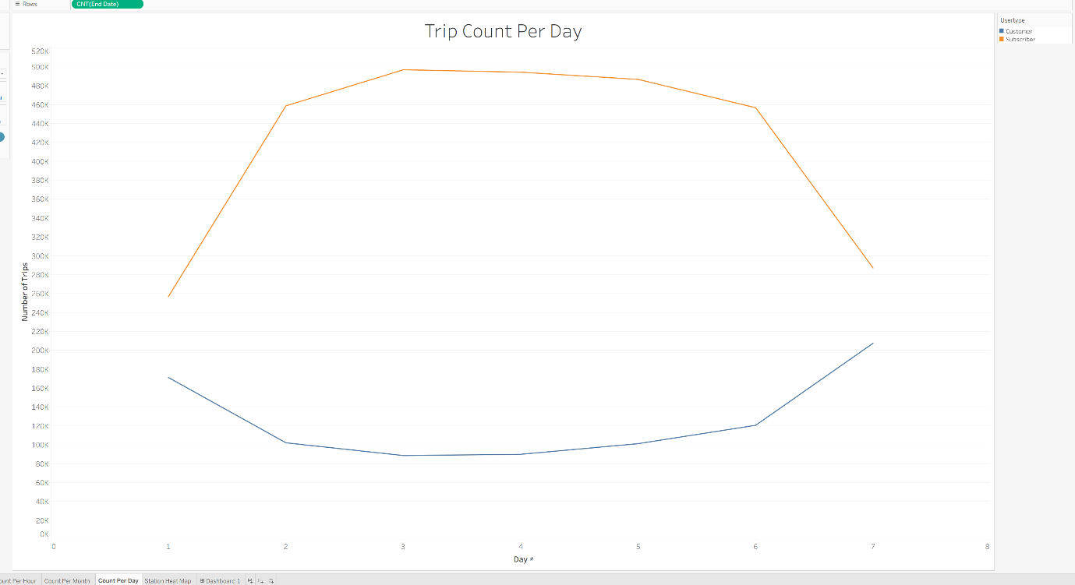
Figure 2: Day of Week
‘Trip Count Per Day’ illustrates the distribution of the total trips throughout the 12-month period by day of the week, amongst casual users and annual members.
The annual members graph illustrates a consistent, high usage rate during weekdays, before significantly declining on the weekend. With the highest volume of trips occurring on Tuesdays [add stat here] and lowest volume occurring on Sundays [add stat here]. This trend further supports the commuter-based user group assumption, intimating a high reliance on the bike-share system for routine travel, before reducing reliance during non-working days.
In contrast, casual users illustrate almost the exact opposite behaviour. The graph shows a consistent, low usage rate during weekdays, before significantly increasing over the weekend. This trend also further supports leisure/recreational-based group assumption, where typical working periods attract significantly less engagement compared to non-working periods [add stat here].
This opposing trends between the two user groups further reinforce the behavioural distinction observed throughout the analysis. Whilst members exhibit consistent weekday usage aligned with habitual travel patterns, casual users display a more recreational weekend-driven pattern.
Application of Analysis
These insights suggest that marketing strategies should be delivered the weekend, whilst casual engagement is at its highest, to maximize conversion likelihood.

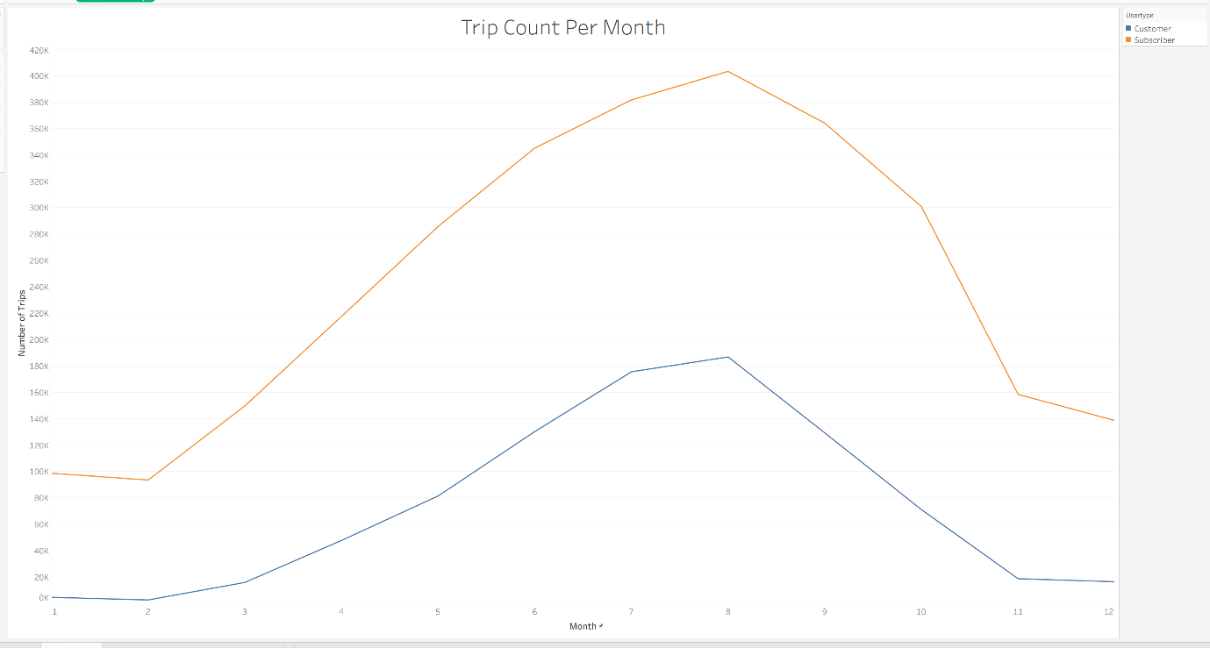
Figure 3: Month of Year
‘Trip Count Per Month’ illustrates the distribution of the total trips throughout the 12-month period by month, amongst casual users and annual members.
In this graph, both user groups follow a similar trend, mimicking a bell curve pattern. It can be seen that a steady increase of engagement occurs from February until August, where it peaks, before steady decreasing until November, where it then remains consistently low until January. Noting that winter typically runs from December to March in Chicago, this behaviour appears to be following seasonal trend. Being that it attracts higher engagement during the warmer seasons and significantly less engagement during the colder seasons due to Chicago extreme weather. Indicating that weather and seasonal conditions play a significant role in overall engagement.
Application of Analysis
These insights suggest that marketing strategies should be delivered during the summer season, whilst casual engagement is at its highest, to maximize conversion likelihood.

6.0 Recommendations

Based on the analysis of user behaviour and engagement data, the following recommendations are proposed for the Cyclictic marketing team:

Target Users During High Volume Periods

Insight:
Casual user activity peaks during late afternoons, weekends, and summer months, indicating higher engagement and greater discretionary time.
Recommendations:
Marketing campaigns aimed at converting casual users should be concentrated during:
- Late afternoon to early evenings during weekdays (4-6pm)
- Weekends, particularly Saturdays
- Summer months (June – August)
Targeting casual riders during these periods maximises exposure and thus increasing the likelihood of conversion to annual membership.

Prioritise conversion of High-Engaging Casual Riders

Insight:
Longer trip durations in casual riders suggest a more intentional and planned behaviour.
Recommendations:
Identify and prioritise casual users who exhibit:
- Longer average trip durations
- Repeated usage
These users should be targeted with tailored conversion incentives, such as:
- Discounted first-year memberships
- Usage-based incentives (e.g “Ride X times, receive membership credit”)
These users exhibit usage patterns that closely align with those of existing members, indicating a strong potential for conversion.

7.0 Appendix
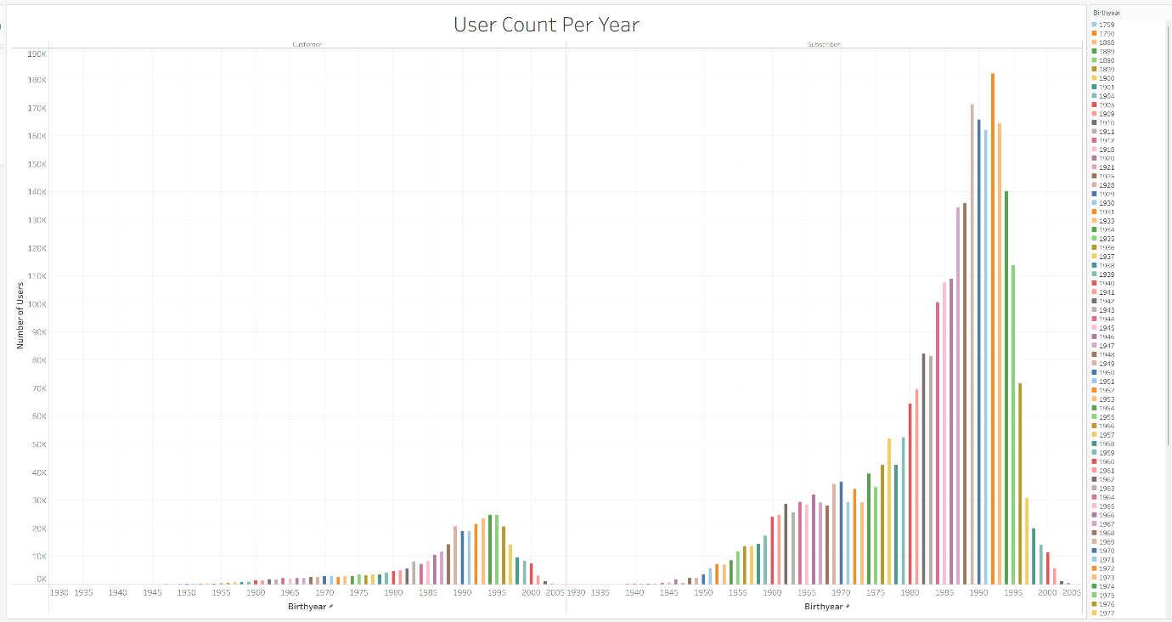
Figure 4: Users Per Birthyear

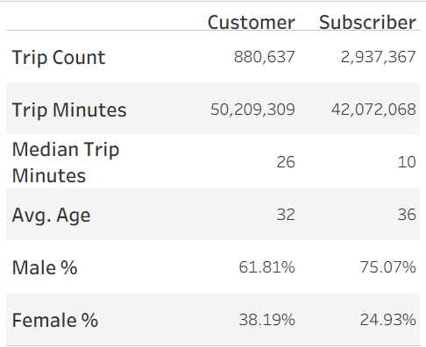

Figure 5: User Type Statistics

